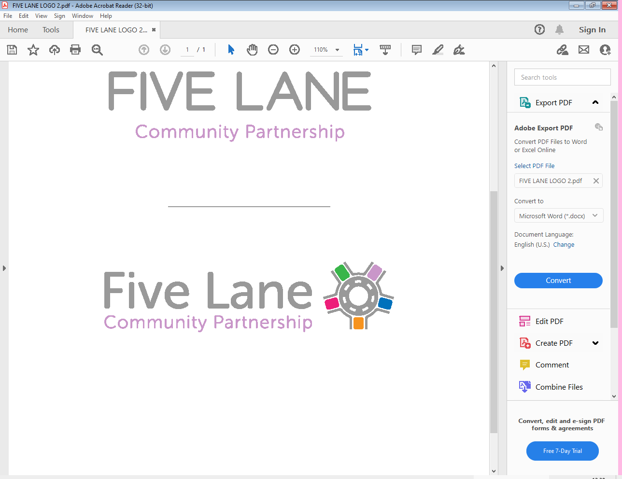

**CHILD DROP IN**

**FLU VACCINATIONS**



Nasal sprays or injections are given to school aged children in reception to year 11. DOB must be between 01/09/2009 and 31/08/2023  
We are offering a **DROP-IN SESSION** to help protect your children against flu this year.  
  
Flu can be a very unpleasant illness for children and can also lead to serious further problems.

***When?*** **Saturday 27th September 2025**

## ***Where?* Moorside Surgery 370 Dudley Hill Road, Eccleshill, BD2 3AA**

## ***What time?* 10.00 am -14:30pm**